**SQL – Assignment-1**

**Task 0:**

Download the data files for this assignment. Your first task is to create tables from these files. In order to do so, please follow the steps given below sequentially:

1. Open MySQL Workbench
2. Connect to your database using the connection you have created
3. Create a database named superstoresDB
4. In the “Navigator” pane on the left hand side, you will find the created database
5. Right click on the superstoresDB
6. You will see the option called “Table Data Import Wizard”. Click on it.
7. Follow the wizard to create tables by providing the .csv data files that you have downloaded
8. You need to follow the “Table Data Import Wizard” for each data file given for this assignment.

Please refer <https://dev.mysql.com/doc/workbench/en/wb-admin-export-import-table.html> to get more information on table data import. Once you are done with this task, attempt following tasks:

**Task 1: Understanding the data in hand**

1. Describe the data in hand in your own words. (Word Limit is 500)

1. cust_dimen: Details of all the customers

**Customer_Name :**  Name of the customer

**Province :** Province of the customer

**Region :** Region of the customer

**Customer_Segment :** Segment of the customer

**Cust_id :** Unique Customer ID

2. market_fact: Details of every order item sold

**Ord_id :** Order ID

**Prod_id :** Prod ID

**Ship_id :** Shipment ID

**Cust_id :** Customer ID

**Sales (DOUBLE) :** Sales from the Item sold

**Discount (DOUBLE) :** Discount on the Item sold

**Order_Quantity (INT) :** Order Quantity of the Item sold

**Profit (DOUBLE) :** Profit from the Item sold

**Shipping_Cost (DOUBLE) :** Shipping Cost of the Item sold

**Product_Base_Margin (DOUBLE):** Product Base Margin on the Item sold

3. orders_dimen: Details of every order placed

**Order_ID (INT) :** Order ID

**Order_Date :** Order Date

**Order_Priority :** Priority of the Order

**Ord_id :** Unique Order ID

4. prod_dimen: Details of product category and sub category

**Product_Category :** Product Category

**Product_Sub_Category:** Product Sub Category

**Prod_id :** Unique Product ID

5. shipping_dimen: Details of shipping of orders

**Order_ID (INT) :** Order ID

**Ship_Mode :** Shipping Mode

**Ship_Date :** Shipping Date

**Ship_id :** Unique Shipment ID

1. Identify and list the Primary Keys and Foreign Keys for this dataset (Hint: If a table don’t have Primary Key or Foreign Key, then specifically mention it in your answer.)

1. cust_dimen

**Primary Key :**  Cust_id

**Foreign Key :** NA

2. market_fact

**Primary Key :** NA

**Foreign Key :**  Ord_id, Prod_id, Ship_id, Cust_id

3. orders_dimen

**Primary Key :** Ord_id

**Foreign Key :** NA

4. prod_dimen

**Primary Key :** Prod_id, Product_Sub_Category

**Foreign Key :** NA

5. shipping_dimen

**Primary Key :** Ship_id

**Foreign Key :** NA

**Task 2: Basic Analysis**

Write the SQL queries for the following:

1. Find the total and the average sales (display total_sales and avg_sales)

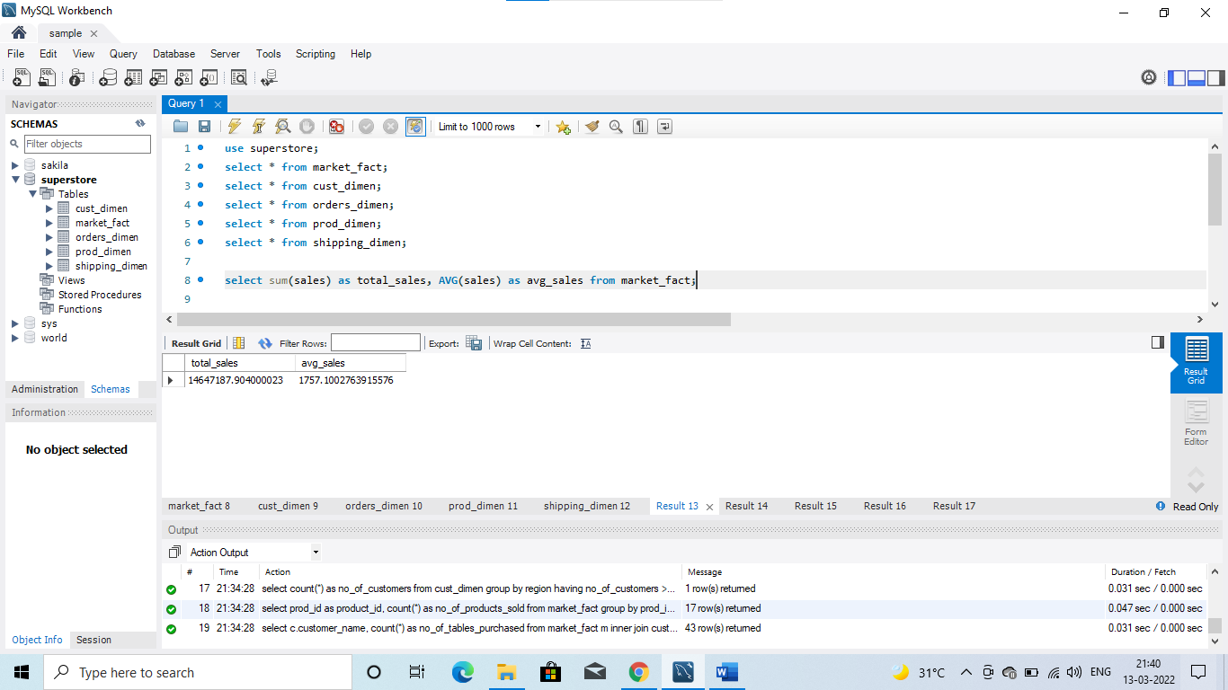

1. Display the number of customers in each region in decreasing order of

no_of_customers. The result should contain columns Region, no_of_customers

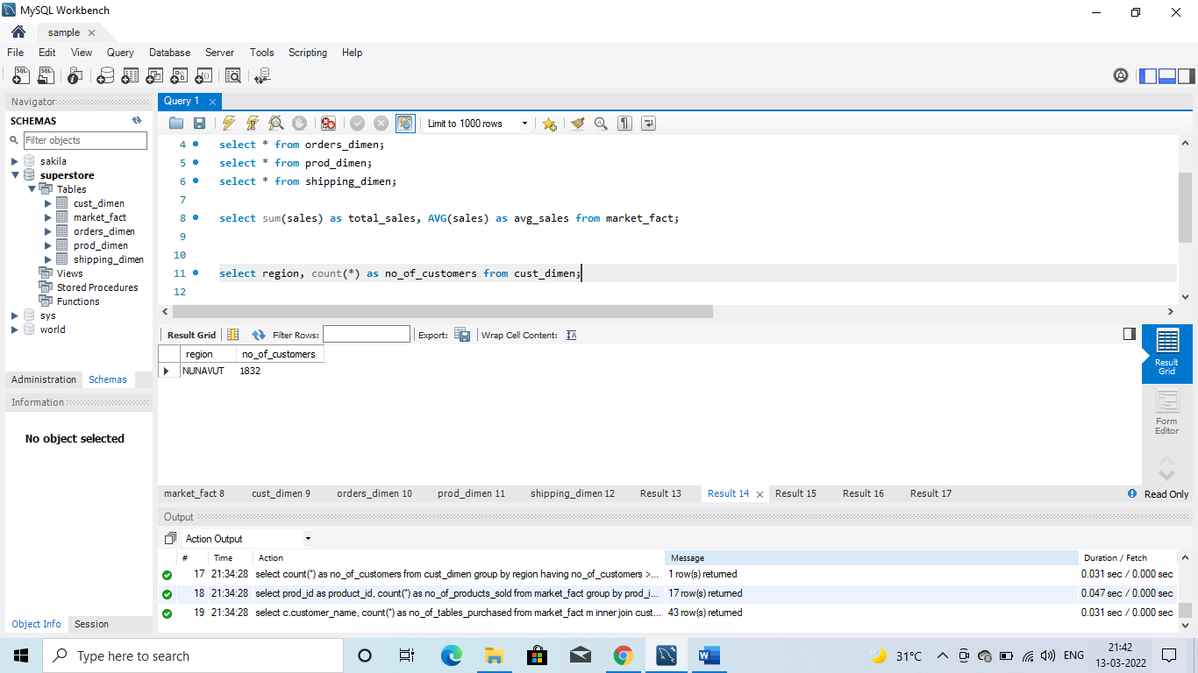

1. Find the region having maximum customers (display the region name and max(no_of_customers)

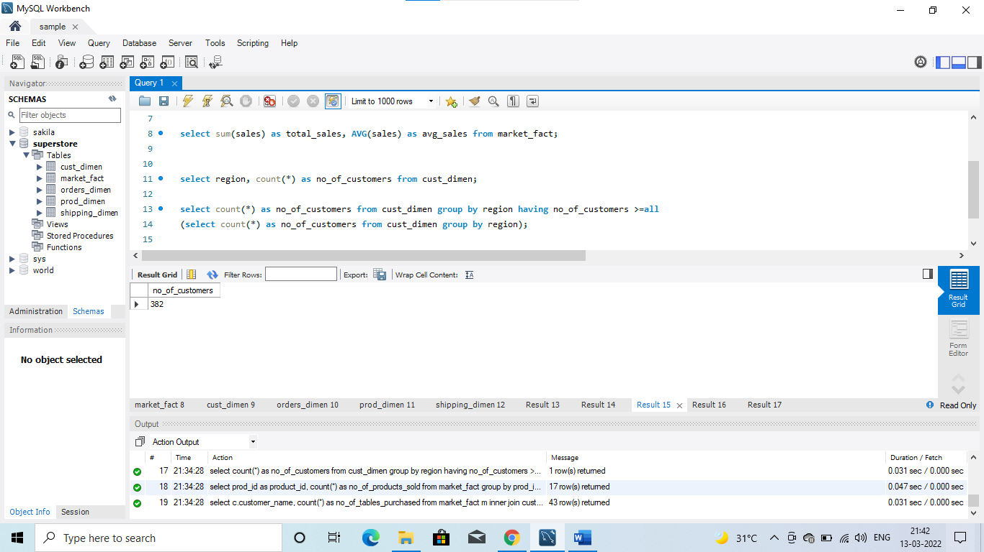

1. Find the number and id of products sold in decreasing order of products sold (display product id, no_of_products sold)

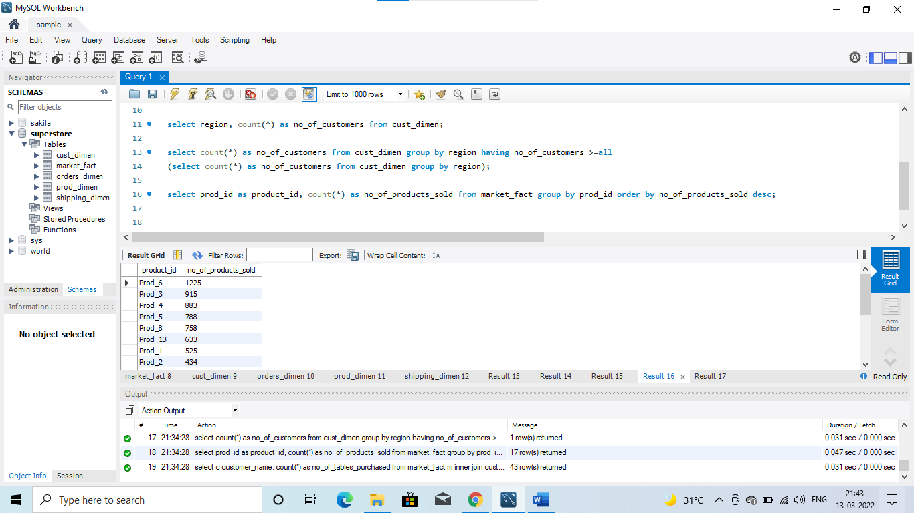

1. Find all the customers from Atlantic region who have ever purchased ‘TABLES’ and the number of tables purchased (display the customer name, no_of_tables purchased)

